Contributor: Mariana Westphalen Von Hartenthal

**Camargo, Iberê**

Born: Restinga Seca, RS, 1914 - Died: Porto Alegre, 1994

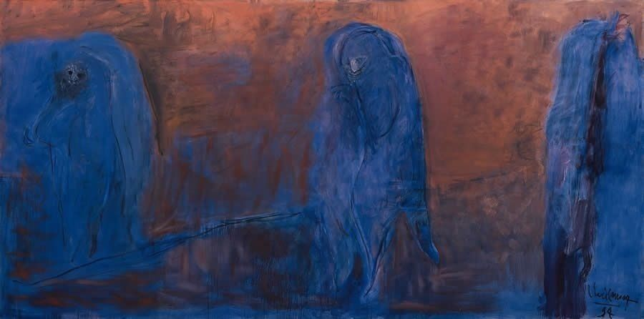

Iberê Camargo, *Solidão* (Solitude), 1994

Oil on canvas

200 x 400 cm

Maria Coussirat Camargo Collection

Iberê Camargo Foundation

Photo: Luiz Eduardo Robinson Achutti

[http://www.iberecamargo.org.br/site/acervo/acervo-obras-pintura-4.aspx#!prettyPhoto[galObrasPinturas01]/7/](http://www.iberecamargo.org.br/site/acervo/acervo-obras-pintura-4.aspx%22%20%5Cl%20%22!prettyPhoto%5BgalObrasPinturas01%5D/7/)

One of the most prominent twentieth-century Brazilian artists, Iberê Camargo remains virtually unknown outside of his country. A painter, printmaker, and draughtsman who created over seven thousand pieces during more than five decades, Camargo never subscribed to the geometric abstraction adopted by more well-known postwar Brazilian artists. He insisted that his works were figurative, even though some of his pieces push the limits between abstraction and figuration, questioning simplistic definitions of these categories. Camargo asserted his independence as an artist who did not follow any school, declining to acknowledge influences. Early in his career, he created landscape paintings and engravings, but in the mid-1950s health problems forced him to stay indoors, directing his attention to objects he could manipulate in the studio. He started the series *Carretéis* (Spools), and developed it for over twenty years; the simple shapes of the objects is deconstructed or used as a structure to organize the surface of paintings and prints. In the series *Ciclistas* (Cyclists), started in the 1980s, expressive brushstrokes delineate figures floating on dark-colored backgrounds, thick with impasto. In the series *Idiotas* (Idiots), disfigured women haunt obscure spaces, as if waiting for someone who will never come.

Camargo began studying painting in 1928, in his native state of Rio Grande do Sul. In 1942, he had his first solo exhibition in Porto Alegre; in the same year he moves to Rio de Janeiro, where he meets artists such as **Cândido Portinari**, Frank Schaeffer, and Hans Steiner. Frustrated with the academicism of the School of Fine Arts, he attended an unaffiliated course taught **by Alberto da Veiga Guignard**. From 1948 to 1950, after receiving the Foreign Travel Award granted by the National Salon of Fine Arts, the artist lived in Europe. In Italy, he took classes with **De Chirico** and Carlo Alberto Petrucci, with whom he kept corresponding after returning to Brazil; in Paris, he studied with André Lhote. The artist spent most of his time in Europe in museums, copying works he admired and making extensive annotations.

Camargo actively participated in Brazilian artistic life, as a teacher, a member of artistic committees, and an activist who denounced the high taxation of imported artistic material during the 1950s, a question that involved hundreds of artists and was closely followed by the press. In 1953, he founded a course on metal engraving in Rio de Janeiro’s Fine Arts Institute, and wrote a book on engraving techniques for students, tiled *A gravura* (The Print), published for the first time in 1955. In 1966, he painted a panel for the World Health Organization’s building in Geneva, commissioned by Brazil’s Ministry of Foreign Affairs.

Camargo’s last painting, *Solidão* (Solitude, 1994) depicts three figures in blue who inhabit the vast space of the canvas, covered in red; they seem detached, isolated from each other. The painting, together with a large part of his production and documents, is housed at the Iberê Camargo Foundation, established in Porto Alegre in 1995.

**References and further reading:**

Camargo, I., and Zielinsky, M. (2006) *Iberê Camargo: Catalogue Raisonné. Vol. 1: Prints*, São Paulo: Cosac Naify.

Siqueira, V. B. (2009) *Cálculo da expressão,* [São Paulo]: Imprensa Oficial.

Siqueira, V. B., and Camargo, I. (2009) *Iberê Camargo: origem e destino,* São Paulo: Fundação Iberê Camargo.

Salzstein, S. (2003) *Diálogos com Iberê Camargo,* São Paulo: Cosac e Naify.

Venancio Filho, P., Camargo, I, and Roesler, S. (2001) *Iberê Camargo: desassossego do mundo*, [Brazil]: S. Roesler: Instituto Cultural The Axis.

**List of Works:**

*Cosme Velho*, 1942. Drypoint on paper. 32,3 x 23,4 cm. Maria Coussirat Camargo Collection. Iberê Camargo Foundation.

*Ciclistas (Cyclists*), 1989. Oil on canvas, 180 x 213 cm. Maria Coussirat Camargo Collection. Iberê Camargo Foundation.

*A Idiota (The Idiot*), 1991. Oil on canvas, 155 x 200 cm. Maria Coussirat Camargo Collection. Iberê Camargo Foundation.

*Carretéis 1 (Spools 1*), 1959. Aquatint (lithographic crayon and sugar process). 45 x 56,3 cm. Maria Coussirat Camargo Collection. Iberê Camargo Foundation.

*Tudo te é falso e inútil II (Everything to You is False and Useless II*), 1992. Oil on canvas. 200 x 236 cm. Maria Coussirat Camargo Collection. Iberê Camargo Foundation.